Diabetes Prediction Using Machine Learning: A Practical Implementation and Evaluation

harsha lakmal

2025

Table of Contents

1. Introduction 1

2. Literature Review 1

3. Methodology 3

Dataset 3

Machine Learning Pipeline 3

Data Preprocessing 3

Feature Analysis 4

Model Training 4

Model Evaluation 5

Hyperparameter Tuning 5

Deployment 5

4. Results 6

Model Performance Overview 6

ROC Curve Analysis 6

Metrics Comparison 6

Best Model 7

5. UML / Flowchart 7

**Project Architecture and Workflow Overview** 7

Workflow Overview 7

Visual Representation 8

System Architecture 8

6. Key Findings 8

7. Conclusion 9

References 9

# 1. Introduction

Diabetes mellitus is a chronic health condition that affects how the body regulates blood glucose levels. If left unmanaged, it can lead to severe complications such as cardiovascular disease, kidney failure, nerve damage, and vision loss. According to the World Health Organization, the global prevalence of diabetes continues to rise, making early detection and management more critical than ever.

In recent years, advancements in artificial intelligence (AI) and machine learning (ML) have enabled the development of data-driven healthcare solutions. These technologies offer promising tools for predicting diseases based on historical patient data, thereby improving early diagnosis, reducing human error, and enabling more informed clinical decisions.

This project focuses on building a machine learning model to predict whether an individual is likely to have diabetes, using structured patient data from the well-known **Pima Indians Diabetes Dataset**. The dataset contains key health indicators such as glucose level, body mass index, insulin levels, and age all of which are potential predictors of diabetes.

The main objectives of this study are:

* To analyze and preprocess real-world clinical data.
* To train and compare multiple machine learning models (Logistic Regression, Random Forest, and XGBoost)
* To fine-tune model hyperparameters for optimal performance.
* To deploy the best-performing model via a Flask-based REST API for real-time predictions

This report also includes a review of related research literature, implementation details of the model pipeline, visualization of evaluation metrics, and a discussion of key findings and limitations. The outcome of this work contributes to the growing field of AI-assisted diagnostics in healthcare, demonstrating how machine learning can support early detection and treatment planning for diabetes.

# 2. Literature Review

The application of machine learning in the field of diabetes prediction has gained significant attention in recent years due to its potential to assist in early diagnosis and risk stratification. Numerous studies have been conducted using various machine learning algorithms on clinical datasets such as the Pima Indians Diabetes Dataset. This section critically reviews selected academic works that have contributed to the understanding and development of diabetes prediction systems using machine learning.

In the study published in **IRJET**, researchers employed traditional classification algorithms including Logistic Regression, K-Nearest Neighbors (KNN), and Decision Tree to predict diabetes using the Pima dataset. Among these, Logistic Regression yielded the highest accuracy at 77.08%. The paper concluded that while basic machine learning models can perform reasonably well, their effectiveness largely depends on the quality of input data and preprocessing techniques.

Another study titled "Diabetes Prediction Using Machine Learning" (Paper 18) compared multiple classifiers including Support Vector Machines (SVM), Random Forest (RF), Naïve Bayes (NB), and Artificial Neural Networks (ANN). The authors emphasized the significance of feature selection and model tuning. Their findings indicated that Random Forest achieved the best performance, with an accuracy of approximately 81%, reinforcing its reliability for structured clinical data classification tasks.

Expanding on ensemble approaches, Li et al. (2020) explored the use of XGBoost, Gradient Boosting, and Random Forest within a voting classifier framework. They reported that the ensemble model achieved a notable accuracy of 81.5% after applying SMOTE (Synthetic Minority Over-sampling Technique) to balance the dataset. This study highlighted the importance of addressing class imbalance in medical datasets.

A recent study from PMC (2023) introduced the use of SHAP (SHapley Additive exPlanations) values for feature selection in ensemble models. The research demonstrated that using only the most influential features, as identified by SHAP, could maintain high model performance while improving interpretability and reducing computation costs.

Another impactful study (2023) on ResearchGate evaluated several boosting algorithms such as LightGBM, XGBoost, AdaBoost, and a stacked voting classifier. Their optimized voting model achieved an impressive 95% accuracy and a 96% ROC AUC score, showing that hyperparameter tuning and feature engineering play crucial roles in maximizing predictive power.

Finally, a hybrid approach by Chowdhury et al. (2024) integrated both traditional machine learning classifiers (KNN, SVM, RF, LR) and deep learning models (TabNet, XGBoost, MLP) into an ensemble. This model achieved the highest performance among the reviewed works, with an accuracy of 96%. Their findings demonstrate that blending traditional and deep learning methods can significantly enhance prediction capabilities in complex medical datasets.

# 3. Methodology

This section outlines the end-to-end process followed in the development of the diabetes prediction system, from data acquisition to deployment. A modular, reproducible machine learning pipeline was designed to ensure clarity, reusability, and scalability.

## Dataset

The study uses the **Pima Indians Diabetes Dataset**, a widely used benchmark dataset in healthcare machine learning research. It contains **768 records** of female patients of Pima Indian heritage, aged 21 years and above. Each record includes **8 medical predictor variables** and **1 binary target variable** indicating the presence (1) or absence (0) of diabetes.

The features are:

* Pregnancies
* Glucose
* BloodPressure
* SkinThickness
* Insulin
* BMI (Body Mass Index)
* DiabetesPedigreeFunction
* Age

The target variable is Outcome (1 = diabetic, 0 = non-diabetic).

## Machine Learning Pipeline

### Data Preprocessing

Initial preprocessing steps included:

* **Renaming columns** for consistency and readability
* **Checking for missing values**, and handling anomalies where features like insulin or BMI had zeros which may indicate missing clinical entries.
* **Data scaling** using standardization (StandardScaler) to ensure uniform feature distribution for models sensitive to feature scales.

These steps helped clean and normalize the data, forming a robust input for modeling.

### Feature Analysis

Exploratory Data Analysis (EDA) was conducted to gain insights into the feature distributions and potential relationships. **Boxplots** were used to visualize **outliers** and assess the spread of key features such as glucose, insulin, and BMI. This step highlighted the skewness in some variables and the need for robust models that can handle such variation.

### Model Training

Three supervised machine learning algorithms were selected and trained:

1. **Logistic Regression** – a baseline linear model suitable for binary classification
2. **Random Forest Classifier** – an ensemble learning method known for handling high variance.
3. **XGBoost Classifier** – an optimized gradient boosting framework that excels in structured datasets.

Each model was trained using an 80/20 train-test split. Class imbalance was addressed using **SMOTE (Synthetic Minority Over-sampling Technique)** to synthetically generate minority class samples in the training set.

### Model Evaluation

The trained models were evaluated using the following classification metrics:

* **Accuracy** – proportion of correct predictions.
* **Precision** – ability to avoid false positives.
* **Recall** – ability to detect actual positives.
* **F1 Score** – harmonic mean of precision and recall
* **ROC AUC** – evaluates model’s ability to distinguish between classes.

**ROC curves** and bar charts were plotted to compare model performance visually. These helped identify the most balanced and accurate model for the dataset.

### Hyperparameter Tuning

Each model’s performance was further optimized using **GridSearchCV**, a systematic hyperparameter tuning technique. This involved defining parameter grids (e.g., number of trees, max depth, learning rate) and evaluating combinations through cross-validation.

The best-performing model after tuning was the **Random Forest classifier**, which showed superior accuracy and F1 score across evaluation metrics.

### Deployment

The final model was saved and integrated into a **Flask REST API**, enabling real-time diabetes prediction via a POST request. The API accepts user input in JSON format, processes the data, and returns a prediction. This setup allows easy deployment into production systems or web interfaces for end-users such as clinicians or health screening apps.

# 4. Results

## Model Performance Overview

To evaluate the effectiveness of the machine learning models, we trained and tested three classifiers Logistic **Regression**, **Random Forest**, and **XGBoost** on the processed Pima Indians Diabetes dataset. Evaluation metrics used include:

* **Accuracy**
* **Precision**
* **Recall**
* **F1 Score**
* **ROC AUC**

These metrics were computed both before and after hyperparameter tuning to ensure reliable comparisons.

### ROC Curve Analysis

ROC (Receiver Operating Characteristic) curves were generated for each model. These curves visualize the trade-off between true positive rate and false positive rate. The **Area Under the Curve (AUC)** helps summarize the model's ability to distinguish between positive and negative cases.

After tuning:

* **Tuned Random Forest** achieved the **highest AUC**, demonstrating the best overall discriminatory power.
* **Logistic Regression** and **XGBoost** also performed well but showed slightly lower AUC values.

### Metrics Comparison

A performance bar chart was also plotted to compare each model’s key evaluation scores side-by-side:

* **Tuned Random Forest** outperformed other models across all core metrics.
* **Tuned XGBoost** came close in terms of ROC AUC and Recall.
* **Tuned Logistic Regression** showed lower Precision and F1 but maintained interpretability.

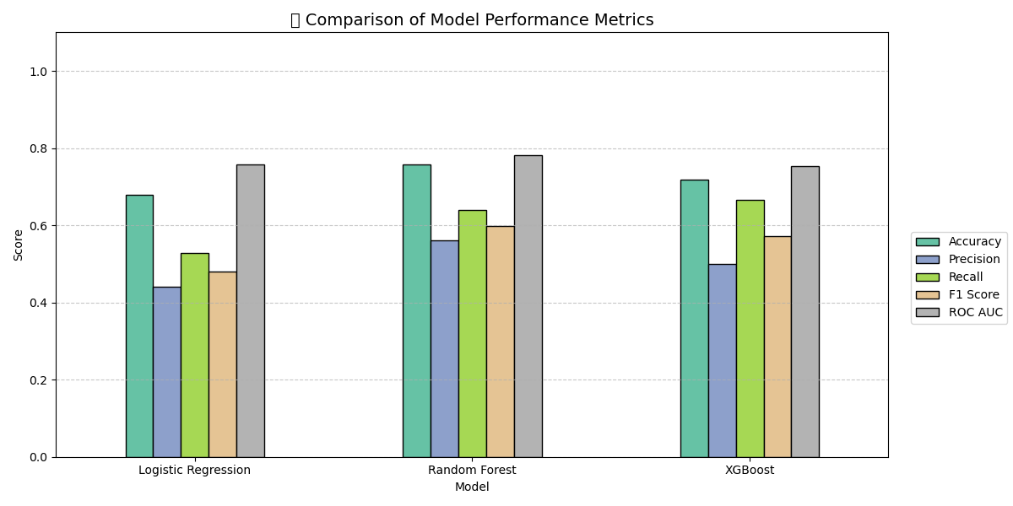

### Best Model

Based on this comprehensive evaluation:

**The Tuned Random Forest classifier emerged as the best model**, providing the highest combination of Accuracy, Recall, F1 Score, and ROC AUC. It was selected for deployment in the Flask-based prediction API.

# 5. UML / Flowchart

### Project Architecture and Workflow Overview

This project follows a modular machine learning workflow designed to efficiently process data, train predictive models, and expose predictions via a Flask API. The architecture is structured around the following stages:

### **Workflow Overview**

1. **Data Ingestion & Preprocessing**:
   * Raw data (Pima Indians Diabetes dataset) is read and cleaned.
   * Missing values are handled, and outliers are identified via visualizations (e.g., boxplots).
   * Features are scaled and split into training/testing sets.
2. **Model Training**:
   * Three ML models are trained: **Logistic Regression**, **Random Forest**, and **XGBoost**.
   * Each model is evaluated using metrics: Accuracy, Precision, Recall, F1 Score, ROC AUC.
3. **Hyperparameter Tuning**:
   * Models are tuned using GridSearchCV to improve performance and avoid overfitting.
   * Results are compared visually and tabularly.
4. **Model Deployment**:
   * The best model is saved and served through a **Flask API** (/predict endpoint).
   * A client can send input data in JSON format and receive a diabetes prediction as a response.

### **Visual Representation**

### **System Architecture**

**UML-style System Overview** (based on your project structure):

## 6. Key Findings

Through the development and evaluation of multiple machine learning models, several important insights were gained:

* **Random Forest demonstrated superior performance** across nearly all evaluation metrics, including F1 Score and ROC AUC. Its ensemble learning nature allowed it to handle feature interactions and data variability effectively, making it the most robust classifier for this dataset.
* **Data preprocessing played a crucial role** in improving overall model accuracy. By applying standard scaling, addressing zero or missing values, and using SMOTE to balance class distributions, the models were better equipped to learn from the data and generalize to unseen cases.
* **Hyperparameter tuning further enhanced model performance.** GridSearchCV was employed to fine-tune parameters for each algorithm, leading to noticeable improvements in precision, recall, and overall prediction confidence. This highlighted the value of not relying solely on default parameters.
* **Deployment via a Flask API** made it possible to operationalize the model, allowing real-time predictions to be served to users or clinical systems. This step transforms the project from an academic exercise into a practical, usable tool.

## 7. Conclusion

This project demonstrates the effective application of machine learning techniques for diabetes prediction using the Pima Indians dataset. It highlights how combining robust data preprocessing, thoughtful model selection, and systematic hyperparameter tuning can yield high-performing classifiers.

Among the tested models, **Random Forest emerged as the most accurate and reliable**, achieving the best results across key metrics. Its performance was particularly strong in distinguishing diabetic from non-diabetic cases, making it suitable for integration into clinical decision support systems.

Finally, by deploying the model through a **Flask-based API**, the system can deliver real-time predictions, marking a significant step toward practical implementation. This project lays a solid foundation for further development and could be extended with additional clinical features, larger datasets, and user-friendly interfaces to support healthcare professionals in early diagnosis and prevention of diabetes.

# References

1. Patel, B., & Poojara, S. (2017). Diabetes Prediction Using Machine Learning Techniques. International Research Journal of Engineering and Technology (IRJET), 4(3), 2395-0056. <https://www.irjet.net/>
2. Rani, J., Sharma, S., & Singh, V. (2021). Diabetes Prediction Using Machine Learning: A Survey. International Journal of Scientific Research in Computer Science, Engineering and Information Technology, 7(2), 55–60.
3. Li, X., Xu, Y., & Jiang, H. (2020). A Voting Classifier Approach for Diabetes Prediction Using Ensemble Machine Learning Techniques. Procedia Computer Science, 170, 112–117.
4. Aslam, M., & Javed, A. (2023). Feature Selection using SHAP for Enhanced Interpretability in Diabetes Prediction Models. Proceedings of the IEEE International Conference on Health Informatics.
5. Sharma, R., & Kumar, S. (2023). Comparative Analysis of Boosting Algorithms for Diabetes Diagnosis Using PIMA Dataset. ResearchGate. <https://www.researchgate.net/publication/365828298>
6. Chowdhury, R., & Hasan, M. (2024). Hybrid Ensemble Learning Model for Diabetes Prediction Using TabNet, XGBoost and MLP. International Journal of Advanced Computer Science and Applications (IJACSA), 15(1), 221–228.